

**Guide to Understanding Catalogs and Online Public Access Catalogs (OPAC)**

**Catalog**

A catalog is a systematic list of all the items available in a library or collection. It as a detailed inventory that helps you know what resources the library has, such as books, magazines, DVDs etc. Each item in the catalog has specific information like the title, author, publication date, and location in the library.

**Online Public Access Catalog (OPAC)**

An Online Public Access Catalog (OPAC) is a digital version of the traditional library catalog. It allows you to search the library’s collection from any computer or mobile device with internet access. You can search by title, author, subject, or keywords to find the resources you need.

The MKUR catalog is an online public access catalog. It can be accessed at

[**https://opac.mku.ac.ke/**](https://opac.mku.ac.ke/)

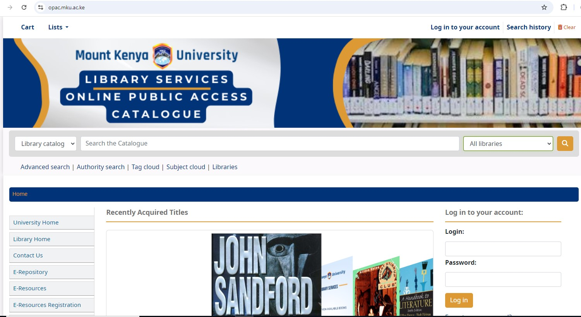

**How to Search Using OPAC:**

1. **Access the OPAC:** Open the library’s OPAC website on your device.
2. **Enter Search Terms:** Use the search bar to type in what you’re looking for. You can search by:
   * **Title** e.g., "The Great Gatsby"
   * **Author** e.g., "F. Scott Fitzgerald"
   * **Subject** e.g., "American literature"
3. Choose Campus as **Kigali Campus Library**
4. **Check Availability:** Look at the search results to see if the item is available. The OPAC will tell you if it’s checked out or available in the library.
5. **Locate the Item:** If the item is available, note down the **Call number** (explained below) to find it in the library.

**Call Number**

A call number is a unique code assigned to each item in the library that tells you where it’s located on the shelves. It acts like an address for the item. It is usually found on the spine of each book as well as on the catalog.

**Composition of a Call Number:**

1. **Classification Number:** This part represents the subject of the item. Libraries often use the Dewey Decimal System (numbers like 813.52) or the Library of Congress Classification (letters and numbers like PS3511.I9).MKUR uses Library of Congress
2. **Author or Cutter Number:** This part represents the author’s last name or the title. For example, “F58” might stand for Fitzgerald.
3. **Publication Year (sometimes):** This indicates the year the item was published, such as “2020” for a book published that year.

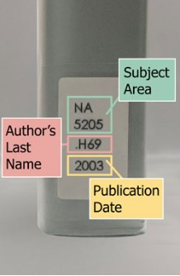

**Identify the Call Number:** After finding the item in the OPAC, write down or save the call number.

**Interpreting Call Numbers**

* **Alphabetical Order**: The letters in a call number are sorted alphabetically. Letters represent broad subjects For example, "B" comes before "C".
* **Numerical Order**: : Numbers following the letters narrow down the subject .Within the same letter range, numbers are sorted numerically. For example, "B 100" comes before "B 200".
* **Decimal Order**: Decimal numbers are used for subjects that are more specific. For instance, "B 100.3" comes after "B 100.2" but before "B 100.4".

**Finding the Right Shelf**

1. **Shelving Range**: Go to the part of the library where that call number is stored. The library is usually organized by the first part of the call number (the classification number).

**Locating the Item-follow the order**

* **Start with the Call Number**: Find the first letter of the call number on the shelf. This will lead you to the general area.
* **Move to the Number**: Within that section, locate the specific number in numerical order. If you are looking for "E 100," find the "E" section and look for books labeled with numbers around "100."
* **Check Decimal Points**: For decimal call numbers, ensure you are placing the item in the correct decimal range. For example, "E 100.3" should be placed after "E 100.2" and before "E 100.4."

**Ask for Help**

* **Library Staff**: If you are having trouble, do not hesitate to ask library staff for assistance. They are usually very knowledgeable about the library’s organization system and ready to assist.

**6. Use Online Catalogs**

* **Library Catalogs**: Before heading to the shelves, use the library's online catalog to verify the exact call number and its location. Log in through <https://opac.mku.ac.ke/> and use your Registration Number and the library password that is **123456**.

**User Support**

* **Workshops and Trainings**: Mention any available workshops or online tutorials that can help users get familiar with the LCC system.